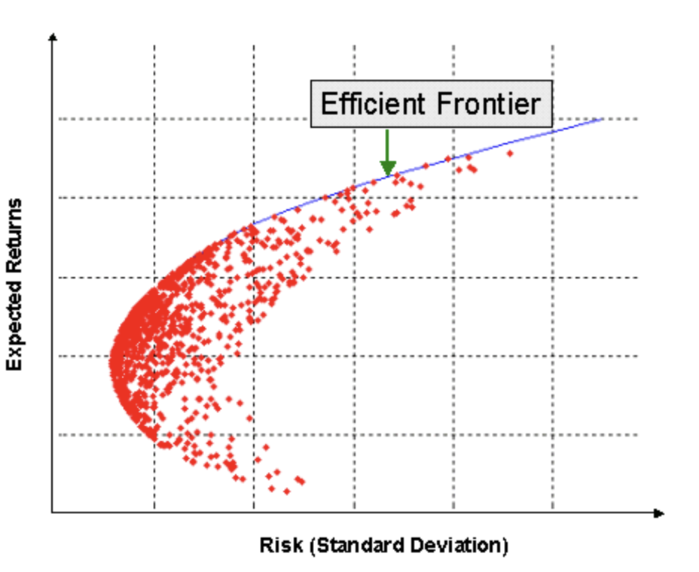

*Figure 1. Efficient Frontier*

**x**

**Efficient Frontier Graph**

**y**

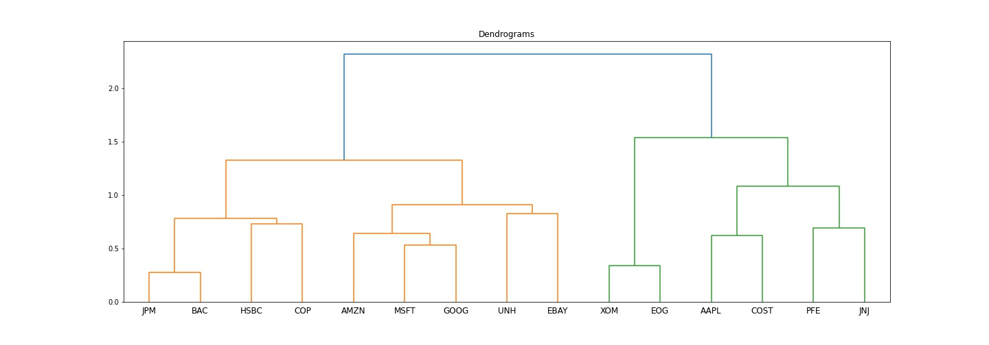

**Dendrogram**

*Figure 2. Dendrogram of Dataset*

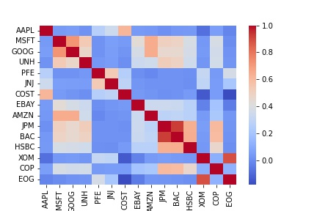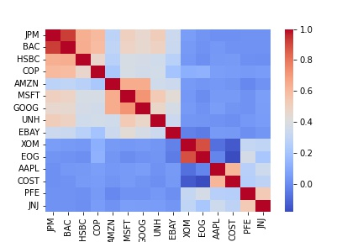

*Figure 3. Correlation Matrix before and after Quasi-Diagonalization*

**Correlation Matrix**

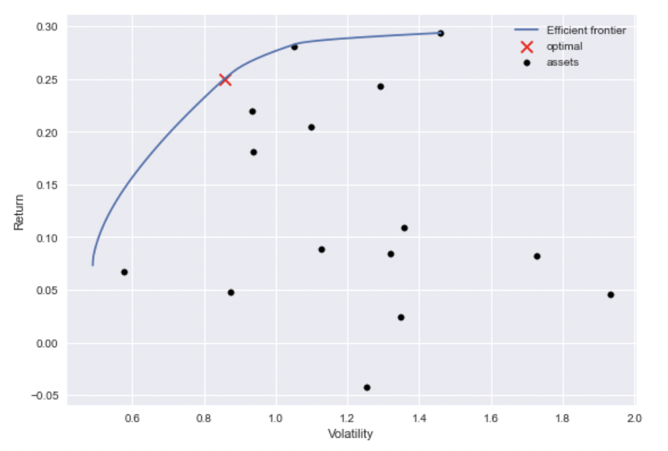

*Figure 4. Efficient Frontier for 2020 MVP Portfolio*

**Efficient Frontier**

*Figure 5. Stacked Area Chart of MVP and HRP Portfolios*

*Figure 6. Expected Returns and Annual Volatility Comparison Chart*

*Figure 7. Backtesting Results*

*Figure 8. Table of Standard Deviation and Sharpe Ratio for Testing Data*